**Pharmacy Management system**

**POC**  
**Low Level Design (LLD)**



Date:

Current Document Version:

DOCUMENT APPROVAL

**Approvers of this document**

|  |  |  |  |  |
| --- | --- | --- | --- | --- |
| **Name** | **Department** | **Role** | **Signature** | **Date** |
|  |  |  |  |  |
|  |  |  |  |  |
|  |  |  |  |  |

**Document Change History**

|  |  |  |  |
| --- | --- | --- | --- |
| **Document Version #** | **Author** | **Date** | **Description** |
| 1.0 | J Raghunath Reddy |  | Pharmacy Management System LLD |
|  |  |  |  |
|  |  |  |  |
|  |  |  |  |

Table of Contents

1.0 Document Purpose 4

2.0 Intended Audience 4

3.0 Project Background, Objective(s) 4

3.1 Project Background 4

3.2 Project Objective 4

4.0 Design Pattern 5

5.0 Solution Diagram 5

**5.1 Solution Diagram**

**5.2 ER Diagram**

**5.3 Use Case Diagram**

**5.4 Data Flow**

6.0 Solution Steps 5

7.0 Classes/function name 6

8.0 Validations 6

9.0 Data model/Tables 6

10.0 API Canvas 6

**11.0 *User Requirements***

12.0 Developer Requirments 7

13.0 AWS Role 7

14.0 HTTP Status Code 7

15.0 Unit Testing 7

16.0 Request 7

17.0 Response 7

# Document Purpose

This document describes the solution architecture for Customer management microservice

# Intended Audience

This document is intended as a reference for the following roles and stakeholders who are interested in the Customer Management Microservice technical architecture.

|  |  |
| --- | --- |
| Role | Nature of Engagement in WB Classics Portal Technical Architecture |
| Product Owners/SME | Key stakeholder to ensure that the architecture is aligned with business goals. |
| Business Analysts | Business analysts are one of the stakeholders who are informed with the key architectural decisions. |
| Enterprise Architects | To enforce Customer management Platform Architecture is aligned to business goals and architecture, architectural guidelines. |
| Solution Architects | To ensure solution design and architecture is aligned to business requirements, architectural guidelines. |
| Developers | Use Technical Architecture Document as the guiding document for detail design and implantation approach to align with Customer management Microservice |

# Project Background, Objective(s)

## Project Background

Pharmacy management system leads to perform Management of Pharmacy where admin or doctor can login whereas admin some set of operations and doctor can do some set of operations.

## Project Objective

Pharmacy management system​ will perform various operations like listing, creation, updating and deletion of Drugs and suppliers, view all the orders the are placed by the doctors, payment process of verified orders and can get the sales report by printing and downloading options. The doctor can check the availability of drugs in pharmacy, place the order according to the requirements and buy the drugs that needed.

Admin/ Doctor can first register themselves and then they can perform all the operations.

# Design Pattern

|  |  |  |
| --- | --- | --- |
| S.No | Name | Description |
| 1 | Angular | Using Angular we can create a single-page application with the help of Typescript and HTML |
| 2 | API | Using HTTP requests, we will use the respective action to trigger various operations |
| 3 | SQL | Used as Database for storing all the details like admin details drug details and doctor-order details |

# Diagrams

5.1 Solution Diagram

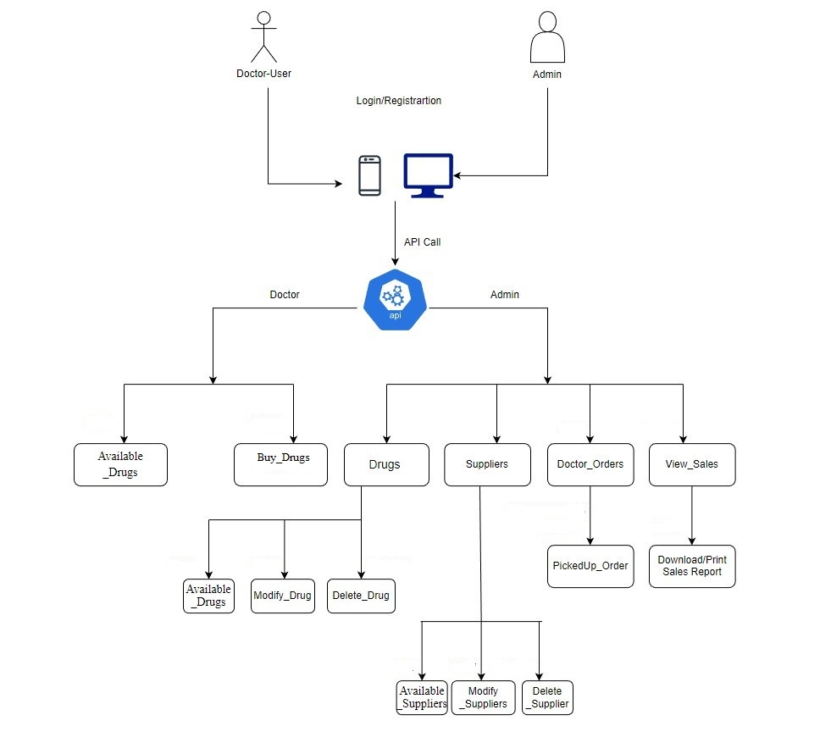

5.2 ER Model: - 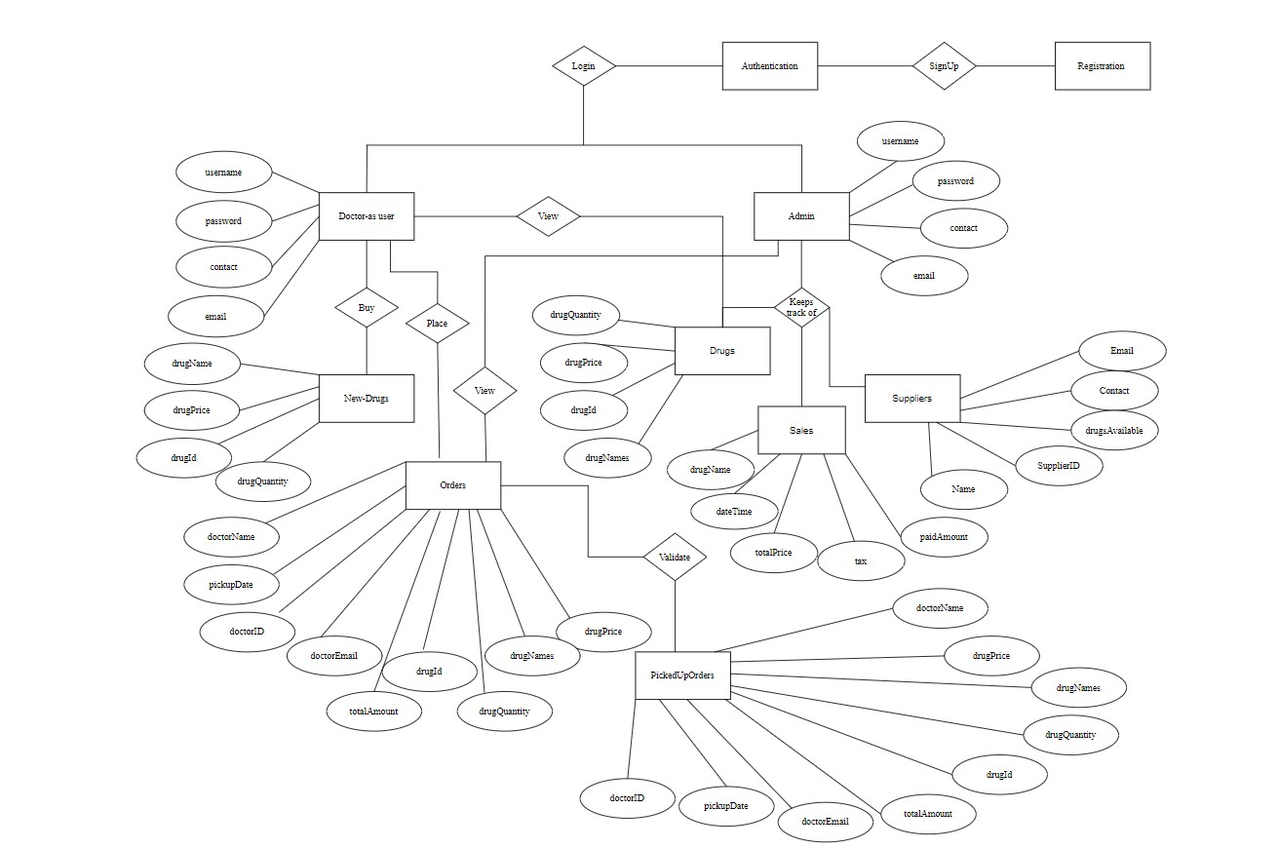

5.3 Use Case Diagram:-

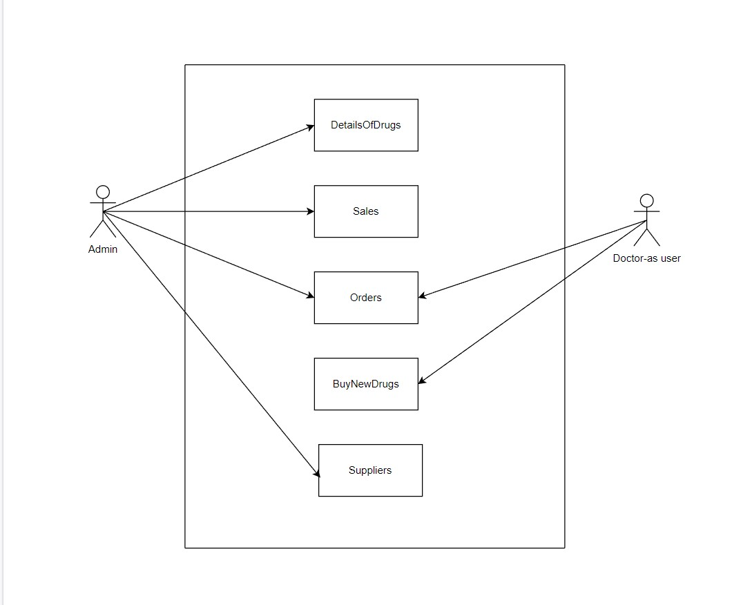

5.3 Data Flow Diagram

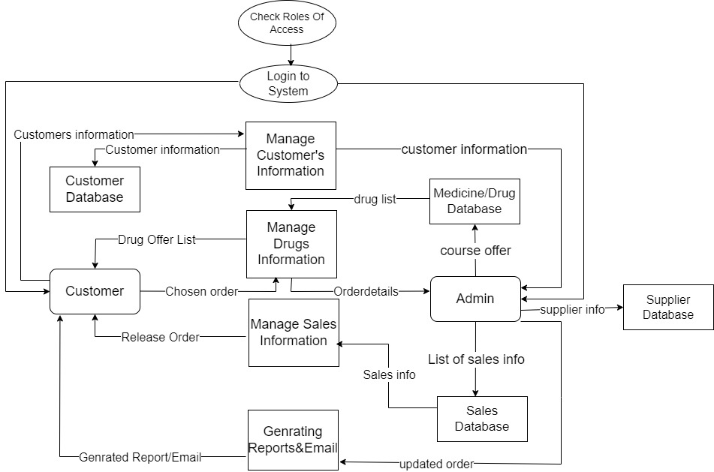

# 6.0 Solution Steps

**Admin Login**

1. The admin will select login and enter the required credentials .
2. There will be only one admin so, the end-user can’t signup as a admin.
3. The input validation will be done
4. If validation fails, then it will return the error code and error description. The JSON response and status HTTP will be returned.
5. If validation is successful, then the admin will get logged in and able to do the operations like, view, update, delete, create. The JSON response and status HTTP will be returned.

**Doctor Registration-as user**

1. The doctor can sign -in with the credentials that he had or he can register by giving the required constrance like email-Id, password, contact, name.
2. Doctor can view all the drugs that are available in the pharmacy.
3. Doctor will order the drugs if needed and then the order will be approved by the admin.

**Drugs Listing**

1. The Admin/Doctor will login using there credentials.
2. The Admin will be able to view all the drugs and admin can also make changes to the already existing drugs where as doctor will only be able view all the drugs that are present and can request a order of drugs if there is no stock for a drug.
3. The Order placed by the doctor will be verified by the admin and then admin will change the field that is valid or not.
4. Based on the verification of admin the order of the drug will be placed and then the JSON response and the status HTTP will be returned.

**Drugs Updation**

1. Admin wants to update the details enters the id and the details which admin wants to update the details. browser directs the request to customer update API
2. Call reaches the API gateway.
3. It sends response body with HTTP Success response code to updateCustomerHandler.
4. updateCustomerHandler returns JSON Response
5. Success JSON response and status HTTP code 200 with corresponding success message.

**Drugs Deletion**

1. Admin eneters the id in parameter for which customer wants to delete the details. browser directs the request to customer deletion API
2. Call reaches the API gateway.
3. doProcess () will call the deleteDrugsService.deleteDrugs() which calls the removeDrugsRepository.removeDrugs() to delete the data from database.
4. removeDrugsHandler returns JSON Response
5. Success JSON response and HTTP status code 200 with corresponding success message.

# 7.0 Classes/function

|  |  |  |
| --- | --- | --- |
| **#** | **Class** | **Description** |
| 1 | Admin.cs | Model holds the Admin schema details |
| 2 | Drugs.cs | This class deals with the data accessibility for Drugs |
| 3 | Supplier.cs | The handler to handle the listing of Suppliers. |
| 4 | User.cs | Model holds the Doctor schema details |
| 5 | Finalorder.cs | This class contains the orders of all users. |
| 6 | UserRepo.cs | This class deals with the data accessibility for doctor registration |
| 7 | Finalorderrepo.cs | The Class contains the data logics used for getting the orders |
| 8 | User.cs | This class deals with data accessibility for customer list |
| 9 | Drugrepo.cs | The handler to handle the CRUD operations for drugs. |
| 10 | IDrugRepository.ts | This class deals with data accessibility for Drug deletion |
| 11 | updateDrugHandler.js | The handler to handle the updation of Drug details in database which calls the updateDrugService class |
| 13 | IDrugRepository.ts | This class deals with data accessibility for customer deletion |
| 14 | OrderValidator.ts | It deals with the validation of the inputs provided by the Doctor-Order |

# Validations



# Data model/Table

|  |  |  |
| --- | --- | --- |
|  | **Drugs** |  |
| PK | Drugid | INT(25) |
|  | drugName | VARCHAR(255) |
|  | drugPrice | FLOAT |
|  | drugQuantity | VARCHAR (255) |
|  | pickupDate | DATE |
| FK | supplierid | INT |

|  |  |  |
| --- | --- | --- |
|  | **DoctorUser** |  |
|  | doctorName | VARCHAR(25) |
|  | doctorContact | VARCHAR(25) |
| PK | doctorID | VARCHAR(25) |
|  | doctorEmail | VARCHAR(255) |
|  | password | VARCHAR(25) |

|  |  |  |
| --- | --- | --- |
|  | **PickedUpOrders** |  |
|  | doctorName | VARCHAR(25) |
|  | doctorContact | VARCHAR(25) |
| Fk | doctorID | VARCHAR(25) |
|  | doctorEmail | VARCHAR(255) |
|  | drugName | VARCHAR(255) |
|  | drugPrice | VARCHAR(10) |
|  | drugQuantity | VARCHAR (255) |
|  | Quantity | INTEGER |
|  | totalAmount | VARCHAR(255) |
|  | pickupDate | DATE |
|  | dateTime | DATE TIME |

|  |  |  |
| --- | --- | --- |
|  | **Sales** |  |
|  | drugName | VARCHAR(255) |
|  | dateTime | DATA TIME |
|  | drugPrice | VARCHAR(10) |
|  | totalPrice | INTEGER |
|  | tax | VARCHAR(25) |
|  | totalAmount | VARCHAR(255) |
|  | balance | VARCHAR(25) |

|  |  |  |
| --- | --- | --- |
|  | **Supplier** |  |
| PK | supplierID | VARCHAR(25) |
|  | name | VARCHAR(25) |
|  | email | VARCHAR(25) |
|  | contact | VARCHAR(255) |
|  | Sales |  |
|  | | |

|  |  |  |
| --- | --- | --- |
|  | Verified Orders |  |
|  | doctorName | VARCHAR(25) |
|  | doctorContact | VARCHAR(25) |
| FK | doctorID | VARCHAR(25) |
|  | doctorEmail | VARCHAR(255) |
|  | drugName | VARCHAR(255) |
|  | drugPrice | VARCHAR(10) |
|  | drugQuantity | VARCHAR (255) |
|  | realQuantity | INTEGER |
|  | totalAmount | VARCHAR(255) |
|  | pickupDate | DATE |

# 10.0 API Canvas

|  |  |  |  |  |  |
| --- | --- | --- | --- | --- | --- |
| Micro Service | Path | Verb | API Description | Role | Auth |
| Buy-New-Drugs | /Order | POST | To Order New Drugs | Doctor | True |
| Drug-Details | /Drug | GET | To get Drug list | Admin | True |
| Update-DrugDetails | /Drug | PUT | To update Drug details | Admin | True |
| Suppliers-Details | /Suppliers/id | GET | To get details of a particular Suppliers | Admin | True |
| Sales-Details | /Sales | GET | To get the Sales of the Pharmacy | Admin | True |
| Update-Supplier | /Supplier/Id | PUT | To update the existing supplier | Admin | True |

# 11.0 User Requirements

# 11.1 Hardware

# • Processor: Minimum 1.8 GHz. Recommended 2GHz or more.

# • Ethernet connection (LAN) OR a wireless adapter (Wi-Fi)

# • Hard Drive: Minimum 100 GB; Recommended 500GB or more.

# • Memory (RAM): Minimum 4 GB; Recommended 8 GB or above.

# • OS: Windows.

# 11.2 Software

# • Any Latest Browsers.

12.**0 Developer Requirements**

12.1 Hardware

• Processor: Minimum 1.8 GHz. Recommended 2GHz or more.

• Ethernet connection (LAN) OR a wireless adapter (Wi-Fi)

• Hard Drive: Minimum 100 GB; Recommended 500GB or more.

• Memory (RAM): Minimum 4 GB; Recommended 8 GB or above.

• OS: Windows.

12.2 Software

• Visual studio 2022.

•Sql server management studio (ssms).

• Node, Angular.

# 13.0 AWS Role

LAMBDA – RDS – Cloud Watch

LAMBDA Invocation

AWS API Gateway

# 14.0 HTTP Status Code

201 – Customer Registered

200 - Request succeeded

400 – Inputs are invalid

404 – Customer Not found

502 – Bad gateway